**Challenge Questions**

**1.) For the initial values of background and inclusion K, plot the flow into the left and out of the right boundary. (The code, as provided, makes this plot for you.)**

* **Explain why the values are not constant along the boundary (relate to the definition of a Type I boundary).**
* **Explain why the flow distributions are the same for the left and right boundaries.**

In this situation, Type I boundary conditions exist at left and right of the domain. This requires the head to be constant at the two domain boundaries at the left and right edges of the heterogeneous domain. In order for constant head to be maintained and for flow to be steady state within the domain, the flow must enter and exit the domain at different rates. This is why the flow exhibits the bell-curve shapes seen on the plot below.

Figure 1: Left and right boundary flows for a heterogeneous flow domain with K = 1, and an inclusion of K = 0.1. Both flows are equal as shown by the plots lining up exactly. Plots 1-4 refer to this domain.

The left and right boundaries also have the same flow profiles because the domain is under steady state conditions. Additionally, the inclusion of low conductivity in the center of the domain is relatively small and while it affects the flow paths in the domain, the flow paths are able to adjust to their original paths before exiting the domain. This results in an equal profile for both the left and right boundaries of the domain.

**2.) Add a plot of the left-to-right flow along a line that passes through the center of the inclusion. What can you learn from comparing this distribution to that seen on the boundaries?**

The flow rate decreases significantly when passing through the low conductivity zone in the domain. Once the flow has passed through the low K inclusion the flux increases to the rate at which it entered the domain and exits the domain at this rate as well. There is a point right at the edge of the domain where flow drops to zero that cannot be accounted for and is likely due to some error in the code. Flow through the center of the inclusion shows that the dip in the flow profiles along the boundaries is due to the low conductivity zone in the center of the domain, as seen below.

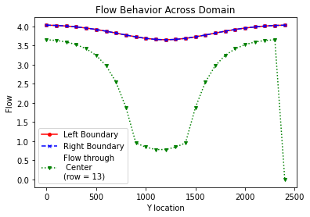

Figure 2: Flow behavior across a center row within the flow domain. The low flow zone indicates the area in the flow domain where conductivity is lower.

**5.) Compare the Keq calculated based on the total flow into and out of the domain to the harmonic and arithmetic mean K values calculated based on the area occupied by each medium (rather than the length for a 1D system). Can you draw any general conclusions about the impact of high or low K heterogeneities on the equivalent K for the flow system examined?**

|  |  |  |  |  |  |  |  |  |  |
| --- | --- | --- | --- | --- | --- | --- | --- | --- | --- |
|  |  | **K = 0.01** | **K = 0.1** | **K = 1** | | **K = 10** | | **K = 100** | |
| **Flux in = Flux out** | | 96.645 | 94.870 | | 104.167 | | 111.683 | | 113.382 | |
| **Keq_flux** |  | 9.487 | 9.665 | 10.417 | | 11.168 | | 11.338 | |
| **Keq_flux_soln** |  | 0.949 | 0.966 | 1.042 | | 1.117 | | 1.134 | |
| **Keq_harm** | | 0.735 | 0.202 | | 1.00 | | 1.037 | | 1.041 | |
| **Keq_arth** |  | 0.960 | 0.964 | 1.00 | | 1.36 | | 4.96 | |

*Figure 3: Flux values for each hydraulic conductivity case, as well as Keq values calculated using flux, the harmonic mean method, and the arithmetic method. Highlighted values of flux were not entirely balanced. Keq_flux values were the original values calculated using an incorrect method, and red values are the corrected values using the shared solution method.*

The higher the K value of the inclusion in the flow domain, the less likely it will be that the various methods of calculating the Keq will agree with each other. When K = 0.01 the values of Keq are all relatively close to one another, but when K = 100 the values of Keq are very different. One other conclusion we can draw from this table is that, at least for this system, the Keq is about two orders of magnitude smaller than the flux in the system.

**Discussion Questions**

**1.) Does the equipotential distribution depend on the absolute or relative K values for the background and the inclusion? How would you use the model to test your answer?**

From looking at the model code and the chart below it appears that the equipotential distribution depends on the relative K values for the background and inclusion. The equipotential lines created here are a result of the head being plotted in a specific way to indicate behavior throughout the domain. The head includes a certain relationship to the K values in the domain. If we changed the code to create equipotential lines for each cell, but still calculated it dependent on the head, this would create lines at the edges of each cell since head is cell centered and K is node-centered. The only way the equipotential distribution would depend on the absolute K is if we changed how the lines were calculated and this would change the nature of the equipotential lines.

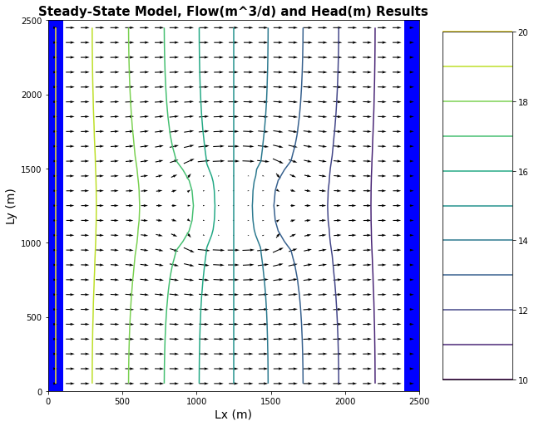

Figure 4: Flow behavior within the heterogeneous domain indicated by arrows for each cell. Head (equipotential lines) indicated by colored lines. Constant head boundaries (left head = 20, right head = 10) indicated by dark blue bars at left and right edges of domain. Low K zone indicated by cinching of equipotential lines and decrease in size of flow arrow size in center of domain.

**2.) Discuss what it means to say that, for steady state flow, there are equivalent Type I and Type II boundary conditions. How might this be useful in practice?**

To have equivalent Type I and Type II boundary conditions means that you have conditions in a flow domain that behave similarly to these boundaries but may not exactly fulfill these cases. For example, instead of having a true constant head boundary you could have a head boundary that is relatively constant while having some other kind of behavior within the system that may compensate for any irregularities in head behavior. I am not sure the exact situation where this could occur, but perhaps it could be possible. It could allow for modeling more complex systems.

**3.) What would you find if you altered your model to consider unconfined conditions?**

The model would likely have much more complicated flow paths and less stable head conditions. Water would be able to move much more freely in the Y or Z directions where it has been relatively constant in those directions throughout our modeling. There would likely be greater uncertainty in prediction which would necessitate consideration of additional environmental factors.

**Glossary Questions**

**1.) What is FloPy? How is it different from MODFLOW and how does it interact with MODFLOW? What are some advantages (easy) and disadvantages (harder) of using FloPy rather than building MODFLOW models manually?**

FloPy is a python package that allows users to read MODFLOW. It is a package within Python that can interact with MODFLOW and build the packages/files that MODFLOW needs in order to run. Using FloPy allows for greater customization of input parameters when setting up a MODFLOW run. However, you do have to make a new notebook for each run?

**2.) Given that the distribution of K is always heterogeneous at the small scale, what does it mean to provide one K value per grid cell? What are the implications for the K values we use in models in general? How does this change if we are modeling with different spatial resolutions (i.e. grid cell sizes)?**

No sub-grid heterogeneity is captured. We have to make sure our K values are different enough that we capture the changes between heterogeneities properly. Also have to make sure that grid cells are small enough that proper spatial resolution is captured.

**3.) What does it mean for a groundwater model to be confined? How does this simplify calculations of groundwater flux? How do we specify this with cell types in MODFLOW?**

We created ztop and zbot in the model and this created a barrier that the model could not cross. If we change this value we can create an unconfined aquifer. We also created this barrier in the way that we set up the x-y grid. We used the dx and dy parameters in FloPy to tell MODFLOW what the boundaries for the domain would be.